A Biblical symbol that is being used in conjunction with the European Union is the one from Revelation 17 where a “great harlot” is depicted riding a beast. This symbol is now being used to represent the European Union! For example, when Great Britain issued a stamp to commemorate the first European Parliament elections in 1979, the picture on the stamp depicted a woman riding a beast.
According to the Dr. Ian Paisley, a Northern Ireland Protestant minister and member of the European Parliament, the woman on a beast is now the official picture of the EU. Dr. Paisley points out that the multi-million dollar new parliament building in Brussels, Belgium, contains a dome with a colossal painting, three times life size, of a woman riding a beast.
In Strasbourg, France, the rival parliamentary building (the one with the Tower of Babel) features a mural of a naked woman riding a beast. Likewise, the new Brussels headquarters of the Council of Europe contains a bronze statue of a woman riding a beast, and the beast is depicted riding on waves, just as in Revelation 17.
Scripture is being fulfilled before our eyes, for those with eyes to see. Who now doubts that the European Union is the 'revived Holy Roman empire' spoken of by the Prophet Daniel and the Apostle John, and the organization from which the Antichrist will rise to power and eventually dominate the world?

NOTE: If you are using OpenOffice, in order to see images, you will need to either click on File, Page Preview, or File, Print Preview. Then, click on Close Preview to return and read the Sermon note.
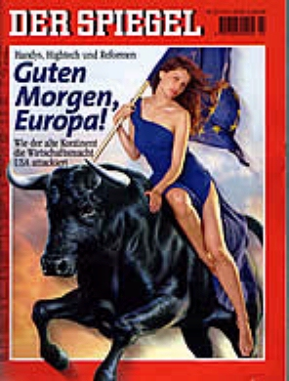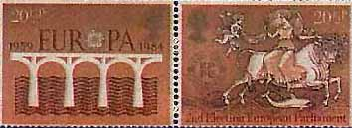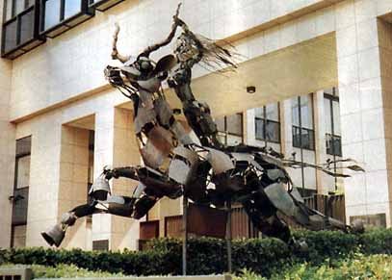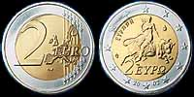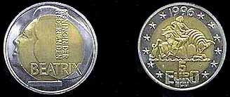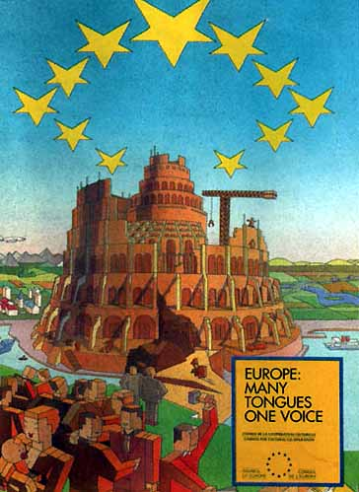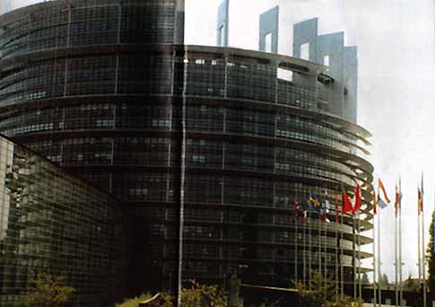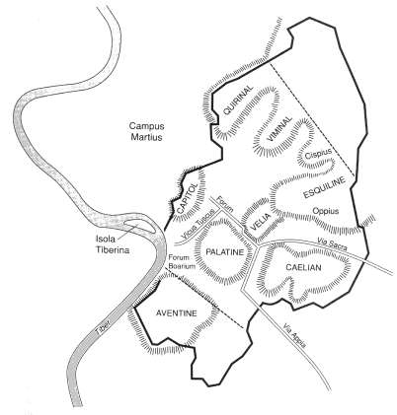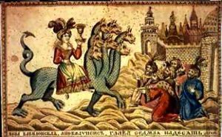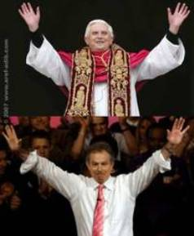

REVELATION 17:1-9......
And there came one of the seven angels which had the seven vials, and talked with me, saying unto me, Come hither; I will show unto thee the judgment of the great whore that sitteth upon many waters: (Revelation 17:1)
With whom the kings of the earth have committed fornication, and the inhabitants of the earth have been made drunk with the wine of her fornication. (Revelation 17:2)
So he carried me away in the spirit into the wilderness: and I saw a woman sit upon a scarlet coloured beast, full of names of blasphemy, having seven heads and ten horns. (Revelation 17:3)
And the woman was arrayed in purple and scarlet colour, and decked with gold and precious stones and pearls, having a golden cup in her hand full of abominations and filthiness of her fornication: (Revelation 17:4)
And upon her forehead was a name written, MYSTERY, BABYLON THE GREAT, THE MOTHER OF HARLOTS AND ABOMINATIONS OF THE EARTH. (Revelation 17:5)
And I saw the woman drunken with the blood of the saints, and with the blood of the martyrs of Jesus: and when I saw her, I wondered with great admiration. (Revelation 17:6)
And the angel said unto me, Wherefore didst thou marvel? I will tell thee the mystery of the woman, and of the beast that carrieth her, which hath the seven heads and ten horns. (Revelation 17:7)
The beast that thou sawest was, and is not; and shall ascend out of the bottomless pit, and go into perdition: and they that dwell on the earth shall wonder, whose names were not written in the book of life from the foundation of the world, when they behold the beast that was, and is not, and yet is. (Revelation 17:8)
And here is the mind which hath wisdom. The seven heads are seven mountains, on which the woman sitteth. (Revelation 17:9)

Showing that hills can be mountains, we look at Psalm 125:2

Psalm 125:2
2As the mountains are round about Jerusalem, so the LORD is round about his people from henceforth even for ever.
Note: Mountains here in the Hebrew means: Mountain, mount, hill, hill country.
They are called mounts, Mount of Olives, etc . . . Hills, mounts, mountains.

The Greek word for mountain: oµrov, which the Transliterated word: Oros means: hill, mount, or mountain. Oros means to rise or to "rear."
Of the Seven Hills of current Rome, five (Aventine, Caelian, Esquiline, Quirinal and Viminal hills) are populated with monuments, buildings, and parks. The Capitoline now hosts the Municipality of Rome, and the Palatine Hill is an archaeological area.
The now-famous Vatican Hill (Latin Collis Vaticanus) is northwest of the Tiber and is not one of the Seven Hills of Rome. (Latin Mons Pincius), to the north, and the Janiculum Hill (Latin Ianiculum), to the west, are not counted among the traditional or original Seven Hills. Likewise, the Pincian Hill
The city of Constantinople (now Instanbul) was built on seven hills, after the City of Rome or copying the City of Rome.
The Whore of Babylon is one of several Christian figures of supreme evil mentioned in the Book of Revelation in the Holy Bible. She, the Whore, is associated with the antichrist and the Beast of Revelation by connection with the kingdom with seven heads and ten horns, and Her apocalyptic downfall is prophesied at the hands of the beast with seven heads and ten horns. What does a whore do? Sell herself for money. Who is this whore? Roman Catholic church.

Rome and the Roman Empire
Many Bible scholars agree that Babylon in the whore's title is meant as an allegory of Rome — perhaps specifically at the time to some aspect of Rome's rule (brutality, greed, paganism), or even a servant people that does the bidding of Rome. The Roman Catholic church's, commentary of the Jerusalem Bible and the evangelical Protestant commentary of the New International Version Study Bible, NIVSB, and the liberal Protestant commentary of the Oxford Annotated Study Bible all concur that "Babylon is the symbolic name for Rome" and that 1st century "Rome" is the "type of place where evil is supreme" (Jerusalem Bible, commentary to Rev. 17).
Elsewhere in the New Testament, written by the Apostle Peter in Rome, 1 Peter 5:13; "Babylon" is used to refer to Rome. This is bolstered by the remark in Revelation 17:9 that she, the Whore of Rome, sits on "seven mountains"(the King James Version Bible-the New International Version Bible uses the words "seven hills"), which are the seven hills (mountains) of Rome. "Rome" would therefore be the 'new Babylon' and all of the symbolism characterizing Babylon as a wanton "whore," would be transferable to Rome, not only in 70 AD, and 135 AD, according to this view, but today to the Roman Catholic church with its worldwide headquarters in Rome.
Rome was a city-state that ruled the known world. There are a number of smaller symbolic clues that some see as suggesting a link between Rome and Babylon — the Roman Empire in its military occupation of Palestine, its repression of the Jewish nation and religion, its destruction of Jerusalem following Jewish revolts in 70AD and in 135AD, and its persecution of Christians, would lend meaning to the imagery of the 'whore, drunk with the blood of martyrs,' as a wantonly violent and bloodthirsty entity in that day, as also representing the Roman Catholic church in persecuting Christians Saints refusing to convert to Worship the pope under the Inquisitions.

Revelation 17:18
18And the woman which thou sawest is that great city, which reigneth over the kings of the earth.
What city-State ruled over the known world? Rome.
Then, from Rome is where the antichrist will come, and where the one who is the Son of Perdition, the betrayer, will come.

John 17:11-12
11And now I am no more in the world, but these are in the world, and I come to thee. Holy Father, keep through thine own name those whom thou hast given me, that they may be one, as we are.
12While I was with them in the world, I kept them in thy name: those that thou gavest me I have kept, and none of them is lost, but the son of perdition; that the scripture might be fulfilled.
Who was the son of perdition? Judas Iscariot. Judas Iscariot was the one who betrayed Jesus Christ, and was called the son of perdition, the betrayer.

Matthew 10:4
4Simon the Canaanite, and Judas Iscariot, who also betrayed him.
Who will be The antichirst? He will be one who claims to know the true and living God through Jesus Christ, but will betray Him, Jesus Christ, by his actions, words, and deeds, following after another God, Mary, and using the God of Forces (Force) to accomplish his deeds.

2 Thessalonians 2:2-4
2That ye be not soon shaken in mind, or be troubled, neither by spirit, nor by word, nor by letter as from us, as that the day of Christ is at hand.
3Let no man deceive you by any means: for that day shall not come, except there come a falling away first, and that man of sin be revealed, the son of perdition;
Where is this man of sin, The antichrist come from? A city-state that rules over the world, from The Seven Hills of Rome (Roman Catholic church. What does he do? He opposeth and exalteth himself above God, and sitting in the temple (Church or Assembly,) shows himself that he is God. Blasphemy!
4Who opposeth and exalteth himself above all that is called God, or that is worshipped; so that he as God sitteth in the temple of God, shewing himself that he is God.

Daniel chapters 2 and 7 reveal a strong connection between the formation of the European Union and end-times Holy Scripture. The fulfillment of this Scripture began in 1950 when the Holy Roman Empire began to show signs of being revived. In 1950 the European Coal and Steel Community was proposed as a means of achieving economic unification in Europe following the war. The hope was that this would strengthen economic trade in Europe. This unified effort led to the signing of the treaties of Rome in 1957, which established the European Economic Community (EEC), and the European Atomic Energy Council. That treaty was taken a step further with the signing of the Brussels Treaty in 1965. The Brussels Treaty began the process of rebuilding the old Roman Empire through reunification of European states under one political system, one economic system, and eventually under the protection of one military force. The treaty established a commission, council, parliament, and court for the union. The revived Roman Empire prophesied in the Bible was well on its way to becoming a reality.
More states were added to this growing union in 1973, 1981, and 1986, making up the 10 permanent member states of today’s European Union. In 2002, the Euro was introduced as the first step toward a unified single currency in Europe. Upon adopting the Euro, Portuguese Prime Minister Antonio Guterres raved, “As Peter was the rock on which the church was built, so the Euro is the rock on which the European Union will be built.” ³
The EU today is made up of over 25 countries, however the ten nations of the Western European Alliance have a separate status as full members, while those nations who joined subsequent to the original 10 have only associate membership, or observer status. This 10 nation military wing of the EU may very well fulfill the prophecy of the beast with 10 horns from Daniel 7:7-8 and Revelations 13:1. On this beast’s back will ride the woman that symbolizes a global religious system that is to appear before Christ returns to set up His kingdom.
The purpose of the EU’s creation was and is, ultimately, to create a European super-state or “United States of Europe”, as some have suggested naming it, that would eventually rival the United States in influence and military might. In 1999, Javier Solana became the High Representative for the EU’s foreign and security policy, and through recommendation 666, he was given emergency powers over the military wing of the EU in 2000. All that currently remains to create a truly revived Roman Empire is the creation of a permanent executive branch of government and the full integration of the new Euro currency. With the introduction of the new EU constitution, the groundwork is being laid for just such an executive branch and economic system.
So how does this all relate to Bible prophecy? Let’s start with the Book of Daniel. Daniel chapter 2 records that the ancient Babylonian King Nebuchadnezzar had a dream concerning the Last Days. No Babylonian could interpret the dream; however, Daniel with God's help, a captive of Judah, was able to interpret Nebuchadnezzar’s dream (Daniel 2:25-30), as God revealed the dream to him (Daniel 2:19-23).
Daniel 2:25-30 says, “You, O king, your thoughts came while you were on your bed about what would happen in the future, and the Revealer of Secrets informed you what will be. As for me, it is not because I possess more wisdom than any other being that this secret was revealed to me, but rather to make the interpretation known to the king, so that you may know what has occupied your thoughts.”

The Prophet Daniel recounted the dream to Nebuchadnezzar, and interpreted the king’s dream of a huge statue by explaining the 4 major components of the statue.
1. A head of Gold
2. Breast and arms of silver
3. Belly and thighs of bronze
4. Feet of iron and clay
These 4 components to represent the 4 major Empires that have existed in the world’s history. The Prophet Daniel confirms that the first of these empires is Babylon, ruled by Nebuchadnezzar.
Daniel 2:37-38 “Thou, O king, art a king of kings; for the God of heaven hath given thee a kingdom, power, and strength, and glory. And wheresoever the children of men dwell, the beasts of the field and the fowls of the heaven hath he given into thine hand, and hath made thee ruler over them all. Thou art this head of Gold.”
Daniel goes on to identify the second and third empires that will emerge following the Babylonian empire.
Daniel 2:39 “And after you will arise another kingdom inferior to you, and [then] another, a third kingdom, of copper, which will rule the whole earth.”
History records the empires that followed Babylon were Medo-Persia and Greece. Daniel 5 tells us that Nebuchadnezzar’s successor, Belshazzar, was conquered by Persia. The second empire of Nebuchadnezzar’s dream was established from modern-day Iran to Asia Minor (Turkey).
The third empire to arise (Daniel 2:39b) and rule the earth was Greece, whose reign began at the time of Alexander the Great. The fourth empire will be a revived model of this Roman Empire. Daniel did, after all, tell Nebuchadnezzar that his vision was about “what will be at the End of Days” (Daniel 2:28). The fourth empire is described as follows:
Daniel 2:40 “It will be strong, yet mixed. It will be a diverse empire (part of potters clay and part of iron, the kingdom will be divided), but will be strong (but there shall be in it of the strength of iron)
Prophecies elsewhere in the Bible also describe this fourth empire of the final days, and by studying these we can examine further any indications that would point to the European Union as the final world empire that will be ruled by the antichrist before Messiah returns.
DANIEL’S VISION OF 4 BEASTS
Following Nebuchadnezzar’s reign, Daniel also had a vision of these 4 kingdoms, but this time they were represented by 4 beasts. (Daniel 7:1-24)
The first beast in Daniel 7:4 is described as being “like a lion, and it has eagles wings”. Interestingly, the emblem of the ancient Babylon was a lion with eagles wings.
The second beast is described in Daniel 7:5 – “Then behold! Another beast, a second one, similar to a bear; it was placed on one side, and there were three ribs in its mouth between its teeth; and this is what they said to it, ‘Arise, devour much flesh!’” The second beast in Daniel 7 is generally accepted as being Medo-Persia because Persia devoured much of the Middle East and Asia, and the Persian Empire had three capitals, Susa, Persepolis, and the conquered Babylon.
Of the third beast Daniel 7:6 says “After this I was watching and behold! Another beast, like a leopard, with four bird’s wings on its back; the beast had four heads, and it was given dominion”. This beast is symbolic of the empire of Greece left behind by Alexander the Great. When Alexander the Great died in 323 C.E., his empire was divided between and ruled by 4 of his generals.
The following verses describe the 4th beast, or kingdom of Daniel’s dream.
Daniel 7:7-8 “After this I was watching in night visions, and behold! A fourth beast, exceedingly terrifying, awesome and strong. It has immense iron teeth, and it was devouring and crumbling, and trampling its feet what remained. It was different from all the beasts that had preceded it, and it had ten horns. As I was contemplating the horns, behold! Another horn, a small one, came up among them, and three of the previous horns were uprooted before it. There were eyes like human eyes in this horn, and a mouth speaking haughty words”.
Daniel 7:23 “Thus he said, the fourth beast shall be the fourth kingdom upon the earth, which shall be diverse from all kingdoms, and shall devour the whole earth, and shall tread it down, and break it to peaces.
In the first verse we see a fourth beast with 10 horns. The small horn, speaking haughty words, rises up and conquers three of them. This represents the antichrist that will come to power through the 4th kingdom. The 10 horns, 3 of which are subdued, are the 10 kings that make up the rulers of the 4th kingdom. From this kingdom and the reign of antichrist will come a global system of government that will rule over the earth prior to the coming of Christ to establish his Kingdom.
Daniel 7:24 “And the ten horns out of this kingdom are ten kings that shall arise; and another shall rise after them; and he shall be diverse from the first, and he shall subdue three kings.”
The office of the pope is called the Papacy, and his dominion the Vatican, from which he is called the “holy see”. In addition to his spiritual role as head of the Roman Catholic church, the pope also has a temporal role (material world or political world) as Head of State of the independent sovereign State of the Vatican City, a city-state and nation entirely enclaved by the city of Rome. The history of the Papacy, then, is the history of both the spiritual role and the temporal role over a timespan of almost 2,000 years from the arrival of Peter in Rome to the present day.
In France in 1796, The Roman Catholic church, the largest landowner in the country, levied a harsh tax on crops known as the dîme. While the dîme lessened the severity of the monarchy's tax increases, it nonetheless served to worsen the plight of the poorest who faced a daily struggle with malnutrition. This is one reason that Napoleon's General Louis Alexandre Berthier, marched into Rome to take the pope captive.
In 538 A.D., the last of three Kingdoms were subdued by the Roman Catholic church, starting the count down of the 1260 days of the 11th Chapter of the Book of Revelation, Revelation 11:2 when Napoleon's General Louis Alexandre Berthier, took the political power of the pope by taking the pope captive.
The three kings (modern day leaders) that are subdued will probably not approve of his, the antichrist's, rise to power or will object to his far-reaching powers. It’s interesting that, prior to the war in Iraq, France, Germany, and Belgium threatened the EU nations that sided with the United States with serious consequences if any EU partner joined the coalition to remove Sadam Hussein.
Recent events may point to the position that the future antichrist will fill in his rise to power. In addition to creating an European Union Constitution, plans are being discussed for an EU Presidency that will replace the current 6 month rotating Presidency, creating a powerful international leader with great influence at the United Nations and on the global stage.
The new President would be elected by government heads of EU members and would hold office for five years. Tony Blair believes this new President “will become the public face and driving force of Europe”. German Foreign Minister Joschka Fischer has gone so far as to say that the Euro was the “first step to a federation”, and he went on to say that he wanted a powerful president of the EU as head of a European government with full legal and executive power. He welcomed the progress made in removing the “sovereign rights” of nations.
We’re given a clue as to the identity of the little horn in Daniel 9:26 – “And after threescore and two weeks and the people of the prince that shall come shall destroy the city and the sanctuary, and end thereof shall be [as swept away] with a flood, and unto the end of the war desolations are determined.”
We know that the people who destroyed Jerusalem (the city) and the temple (the sanctuary) were the Romans. From this people, the Romans or todays Roman Catholic church, shall come the “prince that is to come” or the Antichrist. We can expect then for the Antichrist to rise up from a fourth kingdom that will be the revived Holy Roman Empire.
Daniel 7:25 says, “And he shall speak great words against the most High, and shall wear out the saints of the most High, and think to change times and laws: and they shall be given into his hand until a time and times and the dividing of time.”
The Antichrist will speak blasphemous words against God as he rules over the world, and there will be intense persecution of the tribulation saints, those who accept Christ after the rapture of His church. A time and times and the dividing of time refers to the three and a half years of the Great Tribulation (Revelation 12:14; 13:5).
The European Union is definitely becoming a world power of clay (diversity: peoples accepting others beliefs, and relationships of convenience) and iron (power) with striking similarities to the fourth kingdom or fourth beast of Daniel’s prophecies. A world power of so many ethnic groups and representing so many states would easily become a very influential leader at the United Nations and the world. It’s possible that the U.N. is a beginning for this world government that will eventually be ruled by a revived Holy Roman Empire and the Antichrist.
There are, however, other views on these prophesies that can be considered. Some think that the fourth kingdom is the revived Roman Empire (ten kings are the 10 nation military alliance of the EU) and the U.N. is the 4th beast (10 horns being the 10 bio-regions the UN has established for the globe). Only time will tell which is the case.
I believe the European Union, EU, is the revived Holy Roman Empire that will bring about the rise of Antichrist, then it is important to look at the religious symbolism of the EU. After all, riding on the beast’s back will be the harlot that represents a global pagan religious system that will unite the world and play a part in the persecution of the tribulation saints (Revelation 17).
The EU flag has a circle of 12 stars on a blue background. These stars were inspired by the halo of 12 stars appearing around the Madonna as depicted in Catholic pictures of her. Leon Marchal, former secretary general of the Council of Europe, confirmed that the stars are representative of “the woman of the Apocalypse”. He expounded, “it’s wonderful that we have gotten back to the introit of the new Mass of the Assumption. It’s the corona stellarum duodecim of the woman of the Apocalypse”. He is referencing the woman in Revelation 12 who appears with a crown of 12 stars. The Bible uses this symbolism to represent Israel, however the Catholic Church has always claimed that she represents the Virgin Mary, “the mother of God,” who they Worship as a co-redeemer, one who like Jesus Christ was sinless. A leaflet titled “Building Europe Together” states that “The European flag is a shared flag, blue with 12 gold stars symbolizing completeness. The number will remain 12 no matter how many countries there are in the European Union.”
The anthem of the EU “Ode to Joy” also contains religious symbolism. “Ode to Joy” is the prelude to the last movement of Beethoven’s Ninth Symphony, which has religious implications. EU publications state that the anthem really is an “ode to freedom, community, and peace”, however the lyrics, by Friedrich von Schiller, are actually about the entering of the shrine of a pagan goddess and the uniting of all men in brotherhood, by the power of magic, www.alemattec.com/Black magic practice by the Roman Catholic 'church' . . . Original sin and baptism . . . , tongues, bells, satanism, etc . . . .doc.

Further evidence of a religious side to the European Union is a poster that was issued by the EU, showing the tower of Babel. The poster carried the slogan “Many tongues, one voice.” As if the celebration of the pagan tower that led God to confuse the languages of a defiant people (Genesis 11) isn’t enough, a crane in the background was shown rebuilding the tower. Now, once again, a rebellious people are rebuilding mystery Babylon. In a parliament building in Strasbourg, France, you will find an enormous replica of the unfinished tower of Babel that the secular press has named “Eurobabel”.
If that religious symbolism seems too obscure to be that significant, perhaps a snapshot of Revelation 17 will peak your interest in the religious symbolism of the EU. Revelation 17 depicts a great harlot riding on a beast. The beast in Revelation 17 represents the world government and the great harlot is a global religion that will ride in on its back. This harlot riding a beast was used when Britain issued a stamp to commemorate the first EU parliament election in 1979. It is now the official picture of the EU, and is painted on the dome of the parliament building in Brussels. It is also pictured on the same building that holds the “Eurobabel”.
The EU constitution has also raised the ire of protestant leaders by banning the mention of Christianity as part of Europe’s cultural heritage, while at the same time, including references to the civilizations of Greece and Rome, and the philosophical heritage of the Enlightenment. EU government representatives excused this revisionist view of history by claiming any mention of Christian values would upset the Muslim population of the EU.
As you can see, the stage is being set for the emergence of a global political system (the European Union and the United Nations, www.alemattec.com/The Vatican at the United Nations, A Major Cause for Concern . . . .doc, www.alemattec.com/Who has 'precedence over' Ambassadors at the UN . . . The 'pope' at the United Nations . . . Church or State.doc), a global economic system (the Euro and World Trade Organization, WTO), and a global religious system (the interfaith movement). The EU fulfills many of the prophesies of the fourth kingdom that is to come, from which will arise the Antichrist of the end-times. We are encouraged in the Bible to be aware of the signs, we should all be looking up. We may soon be with our Lord.

Blair speech kindles speculation over EU presidency
http://news.yahoo.com/s/nm/20080112/wl_nm/eu_blair_dc
By Nick Antonovics Sat Jan 12, 9:10 AM ET
PARIS (Reuters) - Former British Prime Minister Tony Blair kindled speculation he was running to be the first president of the European Union by praising the bloc in a speech in Paris as France prepares to oversee the appointment process.
At the invitation of French President Nicolas Sarkozy, Blair told a conference of France's centre-right ruling UMP party on Saturday that EU countries could achieve more in key policy areas by acting together rather than as individual nation states.
"Europe is not a question of left or right, but a question of the future or the past, of strength or weakness," said Blair, speaking in French.
"Terrorism, security, immigration, organized crime, energy, the environment, science, biotechnology and higher education. In all these areas, and others, we are much stronger and able to deliver what our citizens expect from us as individual nations if we are part of a strong and united Europe," Blair said.
The post of president of the European Council -- which meets at head of state and government level usually four times a year -- is due to be created by the 27-nation grouping in the second half of 2008, when France will chair EU ministerial meetings.
Sarkozy already said in October that Blair or Luxembourg Prime Minister Jean-Claude Juncker were obvious candidates. A UMP party grandee, Jean-Pierre Rafarin, wrote in Saturday's Le Monde newspaper that Blair's experience in Europe positioned him well for the European institutions of the future.
Speaking to the UMP conference immediately after Blair, Sarkozy described him as "one of Europe's greats" and praised his role in persuading Britain to sign up to the bloc's new reform treaty.
But he stopped short of offering Blair public backing for the post, which will not be created until the treaty has been ratified by all EU countries.
"When we appoint this president of the European Union, I want us to set the bar high and not aim for the lowest common denominator," Sarkozy said.
Sarkozy said he hoped he would be the last person to hold the bloc's existing six-month rotating presidency before the new president, with a two-and-a-half-year term in office, took over.
Sarkozy said he wanted a political Europe with common energy, immigration and environment policies, but in comments that could create tensions with Blair's successor in Downing Street, Gordon Brown, also pleaded for common agricultural and defense policies.
"Europe can't be an area of 450 million people and one of the richest in the world and rely for its protection on either chance or the United States," Sarkozy said.
"I am a friend of the United States but I insist that Europe give itself autonomous means to defend itself because if one is not capable of this, one is not capable of assuming one's independence," Sarkozy added.
In his speech, Blair praised Sarkozy's leadership and joked that he could quite easily fit in with his government.
In another comment that drew laughter from delegates, Blair cited Sarkozy's "energy, in all areas" -- a reference to the recently-divorced French leader's love affair with a former top model and singer.
--
Paul (<:) Jesus first!
www.Alemattec.com

